Protocol for LSM Image Enhancement:
DM, last updated: 05/01/18
- Start with the .czi image files exported by ZEN after imaging on external HD
  - Suggested Naming Convention (fill in XX’s):
1HLC_HXX_DATEXX_LE/REXX_XXmmHg_SetXX_Stitch.czi
  - Import each .czi file into FIJI, by selecting load/bio-formats. Check split channels and virtual tiff settings and click import
  - Two volumes will open, one for the SHG channel, usually called “0” and one for the TPF channel, usually called “1”. Save each of them by replacing the “=#” at the end with _TPF and _SHG. Save them as virtual tif files. Do this for every .czi image stack from the experiment for every channel (TPF or SHG), duplicate (Sets 1 & 2), and pressure (5, 10, 45 mmHg) and save to an external flash drive.
  - Go over to Latrobe lab 217b, Dr. Yun Chen’s lab, and sit down at the general workstation second to the left, the one with the monitor facing the door. We helped co-purchase the license of Huygens that this lab has and so they said we are free to use it. Log in using password: MAFIA if logged out. Open up Huygens Essentials
  - Import each virtual tiff file one at a time in Huygens Essentials. We have imaging settings files pre-saved for both 0.6x and 0.65x and TPF and SHG with various spacings (3 um or 5 um). Depending on what you used load the appropriate one, click verify settings, and set them.
  - Then open up the deconvolution wizard and click next until you are asked to enter the background value. Enter 10. Click next and set the settings to: SNR: 3, tolerance 0.01, use the default convergence settings. The program will iteratively refine the volume by deconvolution using the provided imaging settings, background value, and signal to noise ratio. When finished it will generate a new deconvoluted image within Huygens. Verify the deconvolution worked by eye (it should look smoother with less noise) then save it to the flash drive using _decon for every tiff file saved from FIJI.
  - Bring the flash drive of deconvoluted data back to your workstation and open FIJI
  - Load each file and duplicate the image stack by clicking, image/duplicate… and checking the box “Duplicate Stack”
  - Open the CLAHE image enhancement file named “CLAHE-IMAGE-ENHANCEMENT.ijm” and click the “Run” button. Wait for the program to enhance the duplicated volume and save it as a new file with _CLAHE
  - Repeat the previous two steps for every deconvoluted volume, both the SHG and TPF volume
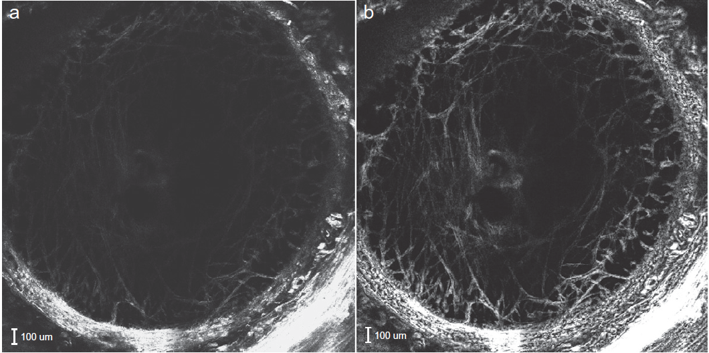
CLAHE Contrast Enhancement at a single depth in the Human LC

