Protocol for Manual Marking of Tissue Interfaces in FIJI for Segmentation:
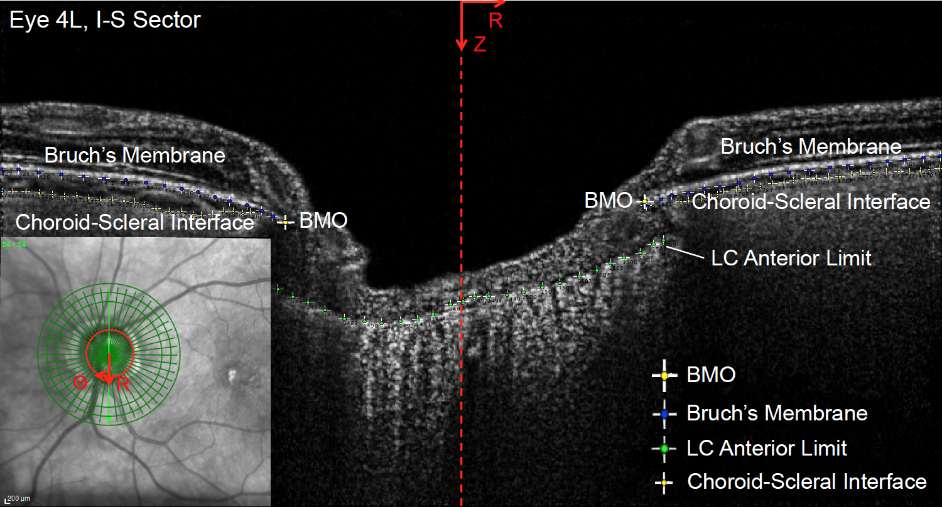
Here is an example of an enhanced radial OCT scan of the human ONH with manual marking of the 4 primary tissue interfaces of interest. I color-code the interfaces and save the marks under a new filename in FIJI with save as > tiff after marking.
Blue – Bruch’s Membrane (Right and left sides)
Yellow – choroid-scleral interface (Right and left sides) we use red now
Green – Anterior LC limit (middle)
Large Yellow – BMO opening (2 points each scan)
If you need instructions on how to delineate or see these features, you can be trained by ophthalmology staff at Dr. Quigley’s Lab. This guide will assume you mostly know how to spot these features.
To mark for a new eye, simply copy one of the tabs in the “RadialDVCResults_ManualMarking.xlsx” file, rename it, and copy in the point series you marked in FIJI as described in the following pages.

Protocol for Manual Marking of Choroid-Scleral Inferface Left/Right Sides:
- Open the program FIJI. Click “accept incoming network connections” if program asks
- Load a contrast-enhanced tiff radial OCT image stack file, corresponding to “before” IOP change: LC068, LC072, LC074, or LC076-LC082. You can do this by file/load or by dragging the image file onto the gray bar on the bottom of the FIJI icon bar.
- Right click on the icon containing multiple points, click “Point Tool”, so the tool switches to manual single-point marking mode. The icon should change to a single point icon.
- Double click on the “point” icon to bring up the “options” list. Select: Type: Hybrid, Color: Red, Size: Large, Check: auto-measure, add to overlay, add to ROI Manager, and label points. Do NOT check auto-next-slice.
- Start marking the choroid-scleral interface on the left side of the first slice. The choroid usually looks like a gray tissue underneath the white line of Bruch’s Membrane broken by the black shadows of wavy capillaries. The scleral tissue is a lighter solid gray and posterior to where the capillaries stop being visible. Once you click the point, it’s RZT (XYZ) position in the image stack will be recorded in a new window that opens. Move over about 15 pixels in X and mark again. You should see the pixel position in XYZ recorded for each point you mark. Do this for a series of at least 15 points, ending as close to the BMO opening as you can see the interface.
- Advance to the next slice by clicking the “arrow button” in the bottom-right corner next to the scroll bar or by scrolling the bar. Repeat step 3 for slices 2-24 on the left-hand side.
- Once you have finished marking the interface on the left-hand side in all 24 slices, highlight all the recorded points with the mouse by clicking the last point, scrolling up to the first point, holding shift and clicking again. Right click and select “copy”. Open your excel file and save the point series with labels as shown in “RadialDVCResults_ManualMarking.xlsx” tab LC068. Paste the R,Z,T marked pixel positions into the “Choroid Sclera Interface Left Side” section of each tab.
- Close the window showing previously marked points in FIJI by pressing the red “x” in the upper-left corner, and click “do not save”.
- Repeat steps 5-8 for the right-hand side of the choroid-scleral inferface, starting marking on the far-right side and traveling to the left. Save in the “Choroid Sclera Interface Right Side” section of the excel file in each tab.
Notes: You can zoom in by pressing command+ if you want to see more of the area. If it is hard to tell where the interface is due to blood vessel shadows, I find it helps to drag the scroll bar on the bottom to see where the interface is in adjacent slices. My summary program sorts the marked points by R and T position, so it is not necessary to mark in strict right-left or left-right order or in slice order when marking boundaries. This allows you to later return, mark, and add new points to the end of the series or in the middle if you feel you want more points. If you ever want to delete a point you just marked: go to the list of recorded points in FIJI, right click, and select “clear”. To delete the point from the image, click on another point to select it, then click on the point you want to delete and press the “delete” button. You need to select another point first to tell the program to go into “select” mode.
Protocol for Manual Marking of Bruch’s Membrane Left/Right Sides:
- Double click on the “point” icon to bring up the “options” list. Select: Type: Hybrid, Color: Blue, Size: Large, Check: auto-measure, add to overlay, add to ROI Manager, and label points. Do NOT check auto-next-slice.
- Start marking the underside (bottom) of Bruch’s membrane interface on the left side of the first slice. The membrane is the largest and bottommost bright, white band below the retina. Once you click the point, it’s RZT (XYZ) position in the image stack will be recorded in a new window that opens. Move over about 15 pixels in X and mark again. You should see the pixel position in XYZ recorded for each point you mark. Do this for a series of at least 15 points, ending as close to the BMO opening as you can see the interface.
- Advance to the next slice by clicking the “arrow button” in the bottom-right corner next to the scroll bar or by scrolling the bar. Repeat step 3 for slices 2-24 on the left-hand side.
- Once you have finished marking the membrane on the left-hand side in all 24 slices, highlight all the recorded points with the mouse by clicking the last point, scrolling up to the first point, holding shift and clicking again. Right click and select “copy”. Open your excel file and save the point series with labels as shown in “RadialDVCResults_ManualMarking.xlsx” tab LC068. Paste the R,Z,T marked pixel positions into the “Bruch’s Membrane Left Side” section of each tab.
- Close the window showing previously marked points in FIJI by pressing the red “x” in the upper-left corner, and click “do not save”.
- Repeat steps 5-8 for the right-hand side of Bruch’s membrane, starting marking on the far-right side and traveling to the left. Save in the “Bruch’s Membrane Right Side” section of the excel file in each tab.
Protocol for Manual Marking of Bruch’s Membrane Opening:
- Double click on the “point” icon to bring up the “options” list. Select: Type: Hybrid, Color: Yellow, Size: Extra Large, Check: auto-measure, add to overlay, add to ROI Manager, auto-advance slice, and label points.
- On the first slice, mark the central endpoint of the left side of Bruch’s Membrane. The volume will auto-advance to the next slice. This is useful as sometimes the opening endpoint is shadowed by blood vessels. If it isn’t clear where the endpoint is you can interpolate by putting it halfway between the scans on either side for continuity. Finish marking the left-hand side of the opening on all 24 slices
- Once you have finished marking the left-hand opening, return to the first slice. Repeat step 2 for the right-hand side of Bruch’s Membrane opening.
- Highlight all the recorded points with the mouse by clicking the last point, scrolling up to the first point, holding shift and clicking again. Right click and select “copy”. Open your excel file and save the point series with labels as shown in “RadialDVCResults_ManualMarking.xlsx” tab LC068. Paste the R,Z,T marked pixel positions into the “Bruch’s Membrane Opening” section of each tab.
- Close the window showing previously marked points in FIJI by pressing the red “x” in the upper-left corner, and click “do not save”.

Protocol for Manual Marking of Anterior Lamina Cribrosa Limit:
- Double click on the “point” icon to bring up the “options” list. Select: Type: Hybrid, Color: Green, Size: Large, Check: auto-measure, add to overlay, add to ROI Manager, and label points. Do NOT check auto-next-slice.
- Mark the anterior LC limit on slice 1 entirely across with points spaced every 10 pixels where possible. Mark everywhere it is visible from the left- to the right-hand side of Bruch’s membrane opening. If the limit is not visible in some areas, skip them and move on to the next visible area. In some eyes the limit is obvious, but in others it is hard to discriminate. I have found in these cases you can usually spot it by flipping between the scans as it tends to move as a continuous line as you advance and can be spotted.
- Repeat Step 2 for all 24 scans.
- Highlight all the recorded points with the mouse by clicking the last point, scrolling up to the first point, holding shift and clicking again. Right click and select “copy”. Open your excel file and save the point series with labels as shown in “RadialDVCResults_ManualMarking.xlsx” tab LC068. Paste the R,Z,T marked pixel positions into the “Anterior Lamina Limit” section of each tab.
- Close the window showing previously marked points in FIJI by pressing the red “x” in the upper-left corner, and click “do not save”.

Import Manual Marks into Matlab:
To use these points for segmentation you must import them into Matlab. You can do so by highlighting the R, Z, T positions of each tissue feature (all 5 one by one) and copying them into matlab. Import as follows via the Matlab Terminal:
- Copy the column Bruch’s Membrane opening. In matlab type: “BMO = [“ then paste the column of RZT pixel positions. Then type “];” and press enter. You have no imported the BMO pixel positions as a 48x3 matrix in matlab.
- Copy the column of the anterior lamina limit. In matlab type: “ALC = [“ then paste the column of RZT pixel positions. Then type “];” and press enter. You have now imported the ALC pixel positions.
- Copy the Bruch’s Membrane Left column. In matlab type: “BML = [“ then paste the column of RZT pixel positions. Then type “];” and press enter.
- Copy the Bruch’s Membrane Right column. In matlab type: “BMR = [“ then paste the column of RZT pixel positions. Then type “];” and press enter.
- Copy the Choroid-Scleral Interface Left column. In matlab type: “CSL = [“ then paste the column of RZT pixel positions. Then type “];” and press enter.
- Copy the Choroid-Scleral Interface Right column. In matlab type: “CSR = [“ then paste the column of RZT pixel positions. Then type “];” and press enter.
- Save all the points by typing the following: “save('LC0XX-dividers.mat','CSL','CSR', 'BML','BMR', 'ALC','BMO'). LC0XX should correspond to the LC number. These points can then be loaded just prior to running the summarize_by_manual_marks_Quadrants function and used to automatically divide the strain fields in the ONH by tissue.

