Protocol for OCT Image Enhancement:
DM, last updated: 02/25/19
Start with radial OCT tiff image series taken of the human ONH at various IOP, provided by the Quigley glaucoma research laboratory. These are folders with the name of the ONH studied: LCXXX with subfolders containing series of 24 images of the ONH, which show the anterior LC, prelaminar neural tissue, retina, choroid, and visible sclera and including a retinal map showing the location of the cross-section the slice was taken at. Scans are separated by 7.5 degrees and comprise a 360-degree cylindrical sampling of the ONH, centered on the LC:
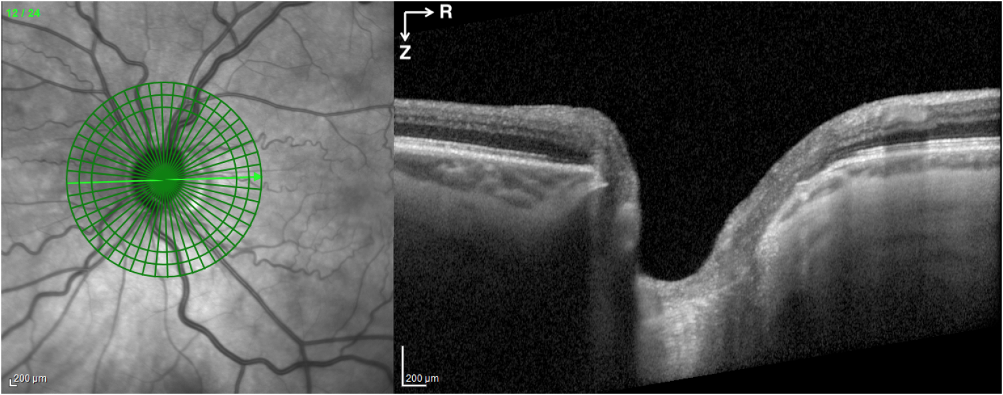
- Copy the matlab file convert_tiff_to_multitiff_radialimagesequence.m into the directory with the 24 radial OCT tiff images
- Open the matlab file in matlab, change the image directory to the current directory, and copy the name of the tiff files up to the digit that changes to represent the image number and insert this name into the fname argument of the matlab file and run. This will crop the ONH images out, removing the scale and retinal map and converting all images into a single multitiff stack that can be opened in FIJI to view all images.
- Move this new file into the main folder outside of the subfolder and repeat for all images at all IOP
- Open the program FIJI. Click “accept incoming network connections” if program asks
- Import each new multitiff file into FIJI for quality analysis. You can do this by file/load or by dragging the image file onto the gray bar on the bottom of the FIJI icon bar.
- Scroll through all 24 images of the each duplicate volume at each IOP and select the “best” image volume for analysis. Issues you should look for are: low noise content, scans not cutting off large parts of the LC or retina (which will look like abrupt ends to the scan, ending in black), and high contrast (center of LC is not just white and oversaturated which can happen if the excitation was too bright). These issues are described in more details with examples of bad images in the powerpoint “Radial OCT Study Summary - June 25.pptx” in the Radial OCT Study Folder of the backup drive for Dan’s Data.
- Select the “best” image volume at the lowest pressure and rename it as _ref1. Select the second best and label it as _ref2. Select the best image volume at all higher IOP and label them as _ref1. These are the only volumes that are needed for DVC analysis.
- If the files are not already named clearly, rename so that it is clear what IOP this scan was taken at and which scan it was (they can have up to 3 duplicate scans)
- Enhance the contrast in each of the chosen volumes by opening the CLAHE image enhancement file named “CLAHE-IMAGE-ENHANCEMENT-enhanceALC.ijm” and click the “Run” button. Wait for the program to enhance the duplicated volume and save it as a new file with _CLAHE.
This script will use contrast limited adaptive histogram equalization to improve contrast and then apply a gamma correction of 1.75 to reduce the brightness of the background and noise.
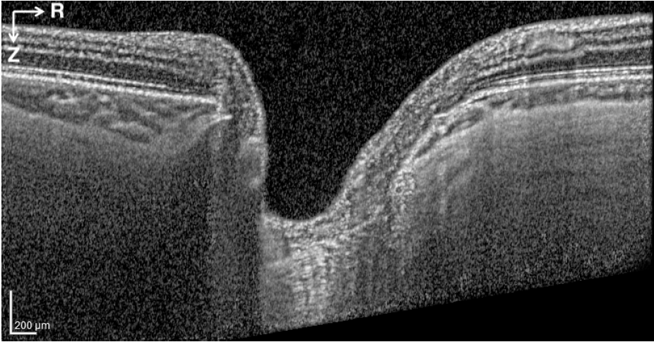
CLAHE Enhancement
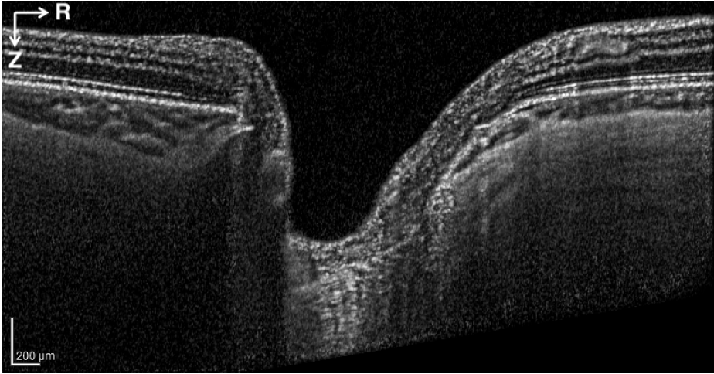
Gamma Correction

